Part II: Data Modeling
BMI is a person's weight in kilograms (kg) divided by his or her height in meters squared. The National Institutes of Health (NIH) now defines normal weight, overweight, and obesity according to BMI rather than the traditional height/weight charts. Overweight is a BMI of 27.3 or more for women and 27.8 or more for men.
(from Wikipedia)
Formulas for BMI
BMI = (Weight in Pounds / (Height in inches x Height in inches)) x 703
BMI = (Weight in Kilograms / (Height in Meters x Height in Meters)) [Metric]

Table 1. BMI Obesity Risk Level for Adults
This is the World Health Organization's (WHO) recommended body weight based on BMI values for adults. It is used for both men and women, age 18 or older.
Risk Category | BMI range - kg/m²
Severe Thinness | < 16
Moderate Thinness | 16 - 17
Mild Thinness | 17 - 18.5
Normal | 18.5 - 25
Overweight | 25 - 30
Obese Class I | 30 - 35
Obese Class II | 35 - 40
Obese Class III | > 40

Table 2. is a lookup table of BMI categories for the US adult population. From https://ehealthrecords.wordpress.com/
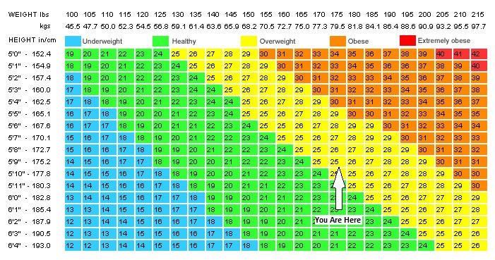

Questions:
- What are the advantages and disadvantages of using a lookup table (table 2) vs. other methods (i.e., formula)
Advantages
The lookup table requires no special training for one to be able to measure their BMI since they only need to be aware of their weight and height. Additionally, the lookup table gives an individual a clear depiction of how healthy they are after determining their BMI.
Disadvantages
The lookup table only factors in adults weighing 45.5 kilograms and those with a height of not less than 5.0". Some individuals are unable to find their weight and height combinations in the table hence being unable to determine their BMI. Also, for one to determine their BMI using the lookup table, they must be aware of their weight and heights, respectively.
- What are the limitations of using table 2 for finding the BMI shown above?
One limitation is that the table is limited to specific weight and height hence not appropriate for all individuals. Utilization of 5tehtable 2 above to measure BMI only takes into account weight and height aspects but ignores the aspect of age. Additionally, men and women have different body fat, but table two assumes that all should have the same BMI as long as they have the same height and weight.
- If you were designing a BMI calculator, what data elements (inputs) would you need to include to make it universal?
The inputs for a universal BMI calculator are weight in either pounds or kilograms and height in meters or inches.
- What other information would you need to include in the design of the universal BMI calculator so that it outputs not only the BMI number but also the obesity risk level?
Other information to include in designing a universal BMI calculator include ranges of BMI, which defines an individual to be underweight, healthy, overweight, or obese. This would enable an individual to determine their obesity risky level hence plan on their weight.
- Describe briefly other methods available to compute BMI.
According to Centers for Disease Control and Prevention, other methods that can be used to calculate BMI include CDC table for calculated body mass index , metric systems (uses weight in kilograms and height in meters), and English systems (uses weight in pounds and height in inches).
- Is there a commercially available device which computes BMI? Explain what it is and what methodology it utilizes.
There is a BMI calculator app that can be downloaded from the App Store or Play Store, which is used by many to compute BMI. The calculator is downloaded and installed in mobile gadgets where an individual can enter their weight and height then compute their BMI more precisely at any moment they need.

